

SAMS Driver Manager
User Manual
Illustrated operating guide
Version 1.40.34 Production Candidate 1
Driver sign-in • inspections • photos • offline Queue • reminders • session controls

Contents
1. Purpose and operating principles
2. Sign in and identity verification
3. Driver licence expiry reminder
4. Driver Entry
5. Defect checklist
6. Service photos
7. Submit and confirmation
8. Offline operation and Queue
9. Session Buses
10. Safety Reminders
11. Inactivity and automatic sign-out
12. Settings and User Manual
13. Troubleshooting
14. End-of-session checklist
Graphic walkthroughs
Sign-in and identity verification
Licence expiry reminder
Driver Entry and bottom action bar
Defect checklist
Vertical service-photo previews
Safety Reminders
Offline Queue workflow
Session Buses
Inactivity warning and automatic sign-out
Settings and in-app User Manual

Quick Start
Step | Action | What to do
1 | Sign in | Enter employee information and complete licence/employee photo verification.
2 | Enter bus details | Bus Number, Mileage and Parking Location are required.
3 | Inspect and document | Check observed defects, describe affected areas and add photos when useful.
4 | Submit once | Wait for confirmation. Verify the bus in Session Buses.
5 | Check Queue if offline | Pending records are kept locally and synchronize automatically when connectivity returns.
6 | Sign out at end of shift | Review Session Buses and Queue first; then end the session.
Important: Do not clear site data or IndexedDB while offline Queue records may be pending.

1. Purpose and operating principles
SAMS Driver Manager records yard bus servicing and inspection information. Use the app for each bus handled during the session. Enter accurate bus, mileage and parking information; select only defects actually observed; add supporting photos when helpful; and verify that the submission reached the server or is safely retained in the offline Queue.

2. Sign in and identity verification
Enter your name, facility and employee ID. Photograph the original physical driver licence and then take the employee photo. The app compares the faces before opening Driver Entry. Use good lighting, avoid glare and keep the complete licence visible.
- Use the original physical licence, not a photo displayed on another screen.
- Keep the licence flat, well lit and fully visible.
- The employee photo should clearly show one face.
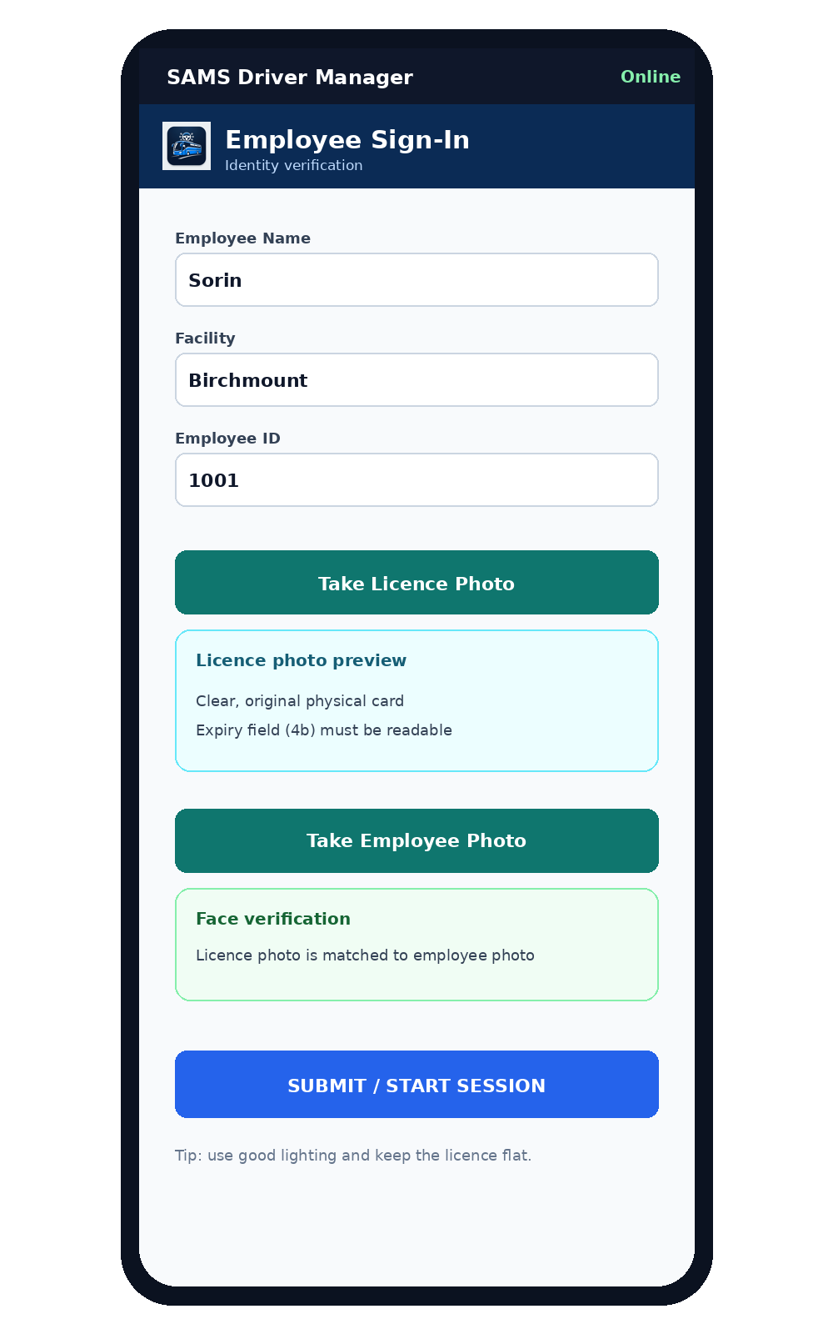
Illustrated screen: Sign-in and identity verification

3. Driver licence expiry reminder
The expiry date is read from the licence photograph. A renewal reminder appears only when the expiry is within approximately one month (31 days) or the licence is already expired. If the expiry date cannot be read reliably, the app does not show a renewal warning.
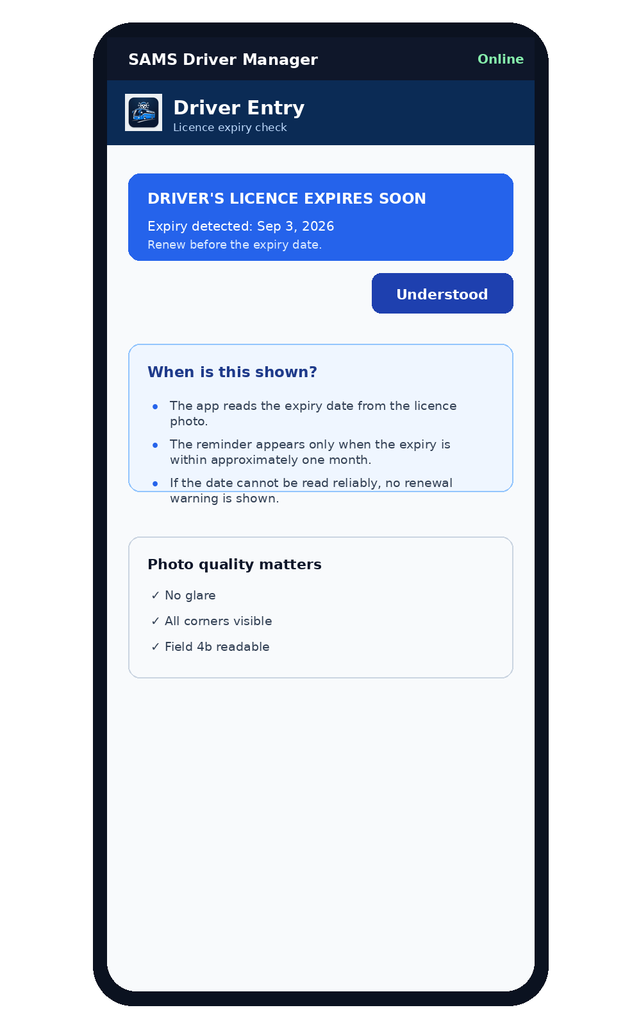
Illustrated screen: Licence expiry reminder

4. Driver Entry
Enter the four-digit Bus Number, the current Mileage and the Parking Location. The connection indicator shows Online or Offline. Review the information before moving to the defect checklist.
- Bus Number must contain exactly four digits.
- Mileage accepts up to seven digits.
- Parking Location should match the actual yard location.
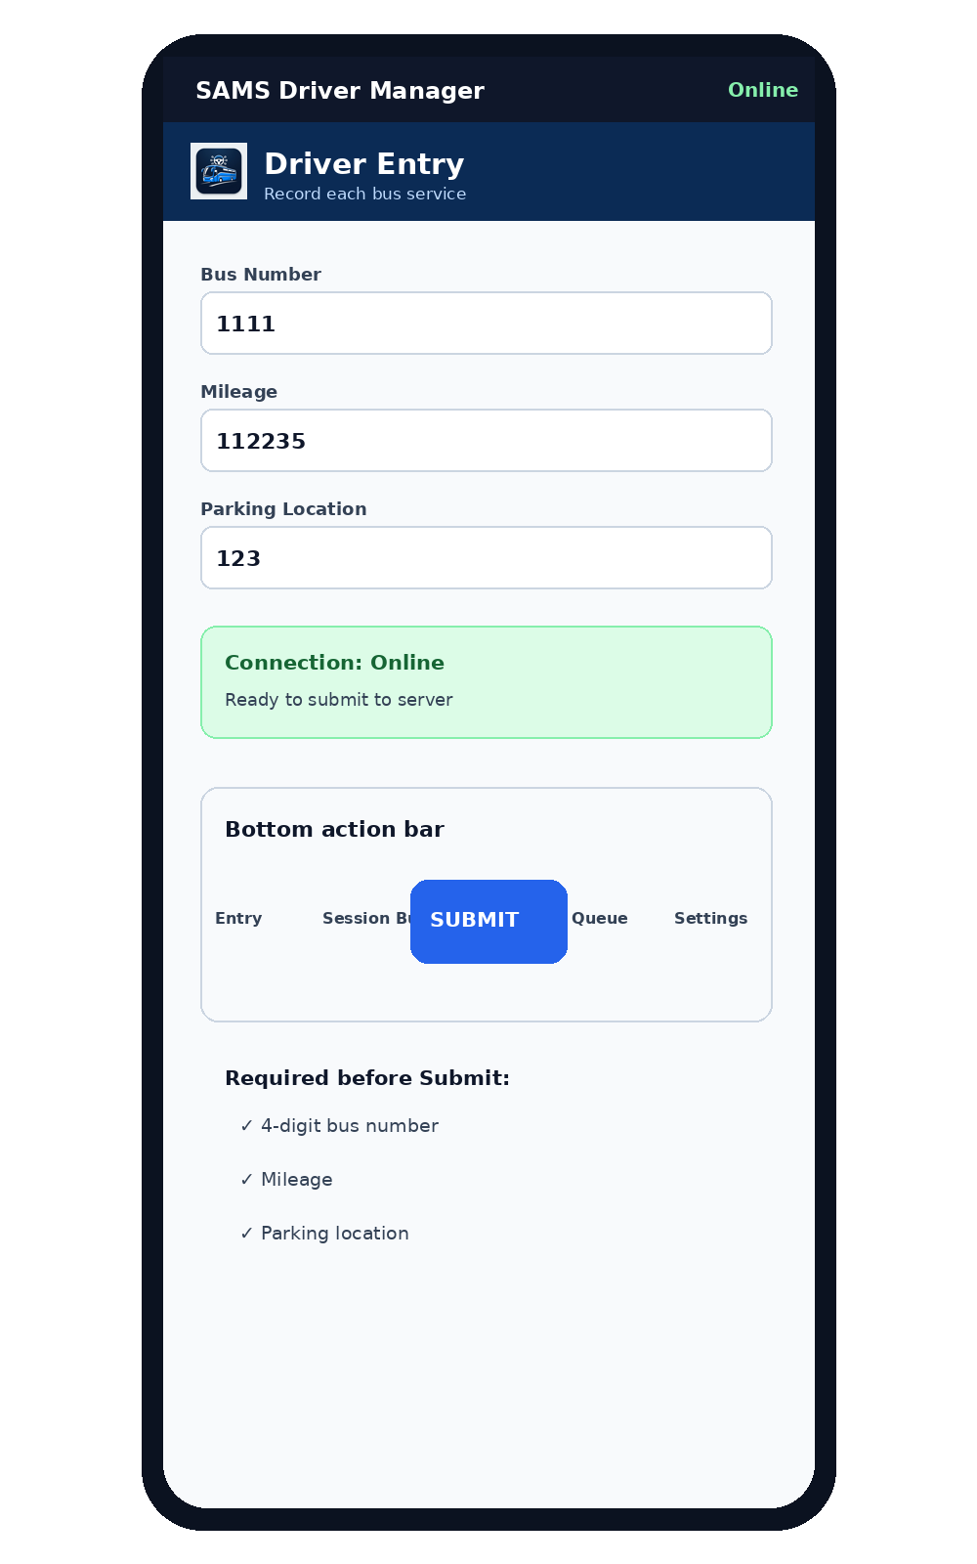
Illustrated screen: Driver Entry and bottom action bar

5. Defect checklist
Check an item only when the listed condition is observed. Leave the item unchecked when no defect is observed. The checklist contains Exterior, Interior, Indicator Lights, Operator Controls and Ancillary System categories. Use the Affected Area box to describe location, severity or other relevant details.
- Check only observed defects.
- Use Affected Area for clarification and location details.
- Review all categories before submitting.
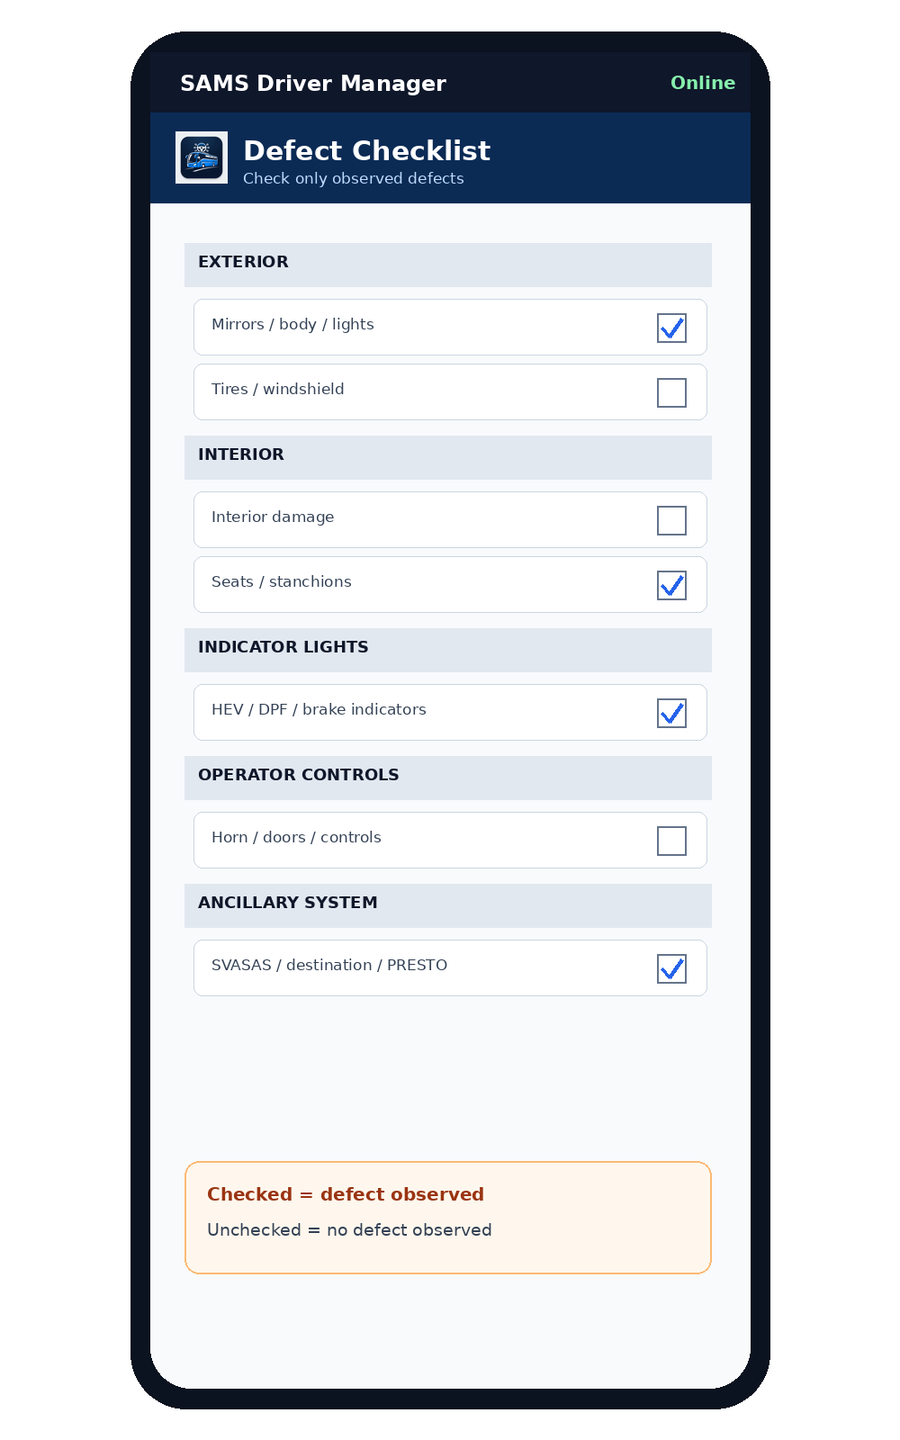
Illustrated screen: Defect checklist

6. Service photos
Up to three service photos may be attached. Use the in-app camera buttons. The app compresses photos before upload to reduce memory use and transfer time. The previews appear vertically, one below another. Confirm each preview before submitting.
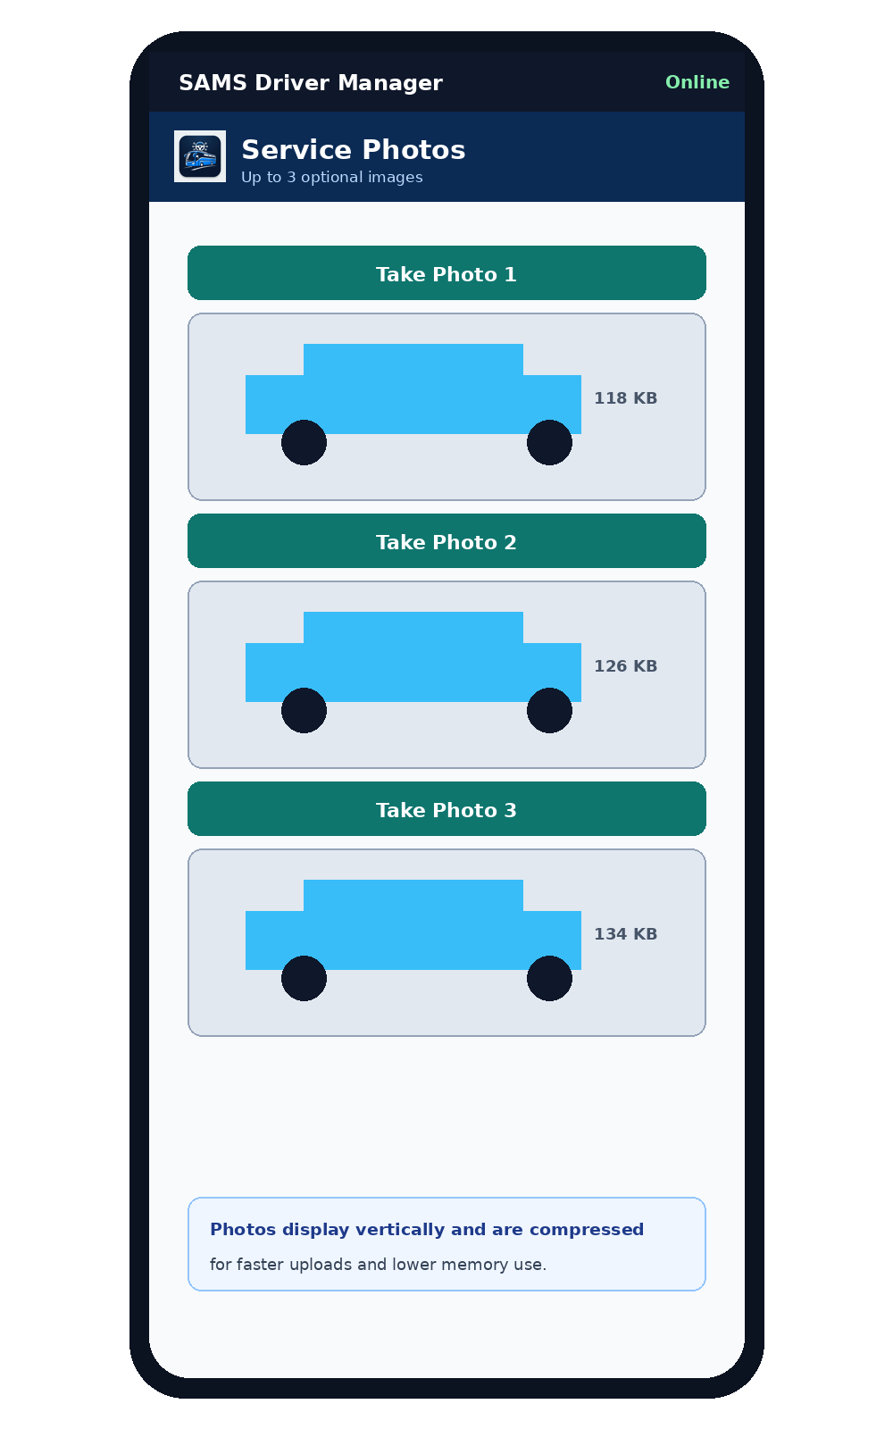
Illustrated screen: Vertical service-photo previews

7. Submit and confirmation
Press SUBMIT once. The app validates required fields, prepares the payload and sends it to the server when connectivity is available. A successful confirmation is shown briefly and the bus is added to Session Buses. Do not repeatedly press Submit if the result is uncertain; check Session Buses or the server record first.
- Watch for visible Preparing/Submitting status.
- A successful message disappears automatically after a few seconds.
- Use Session Buses as the operational confirmation view.

8. Offline operation and Queue
When the server cannot be reached, the record is stored on the device and shown as In Queue. The Queue is preserved across app restarts and sign-out. Automatic synchronization retries pending records when connectivity returns and while the PWA is open. Retry All is available for pending uploads but automatic synchronization is the normal workflow.
- Queued records survive normal sign-out and PWA restart.
- Automatic synchronization is preferred over repeated manual retries.
- Do not clear storage when records are pending.
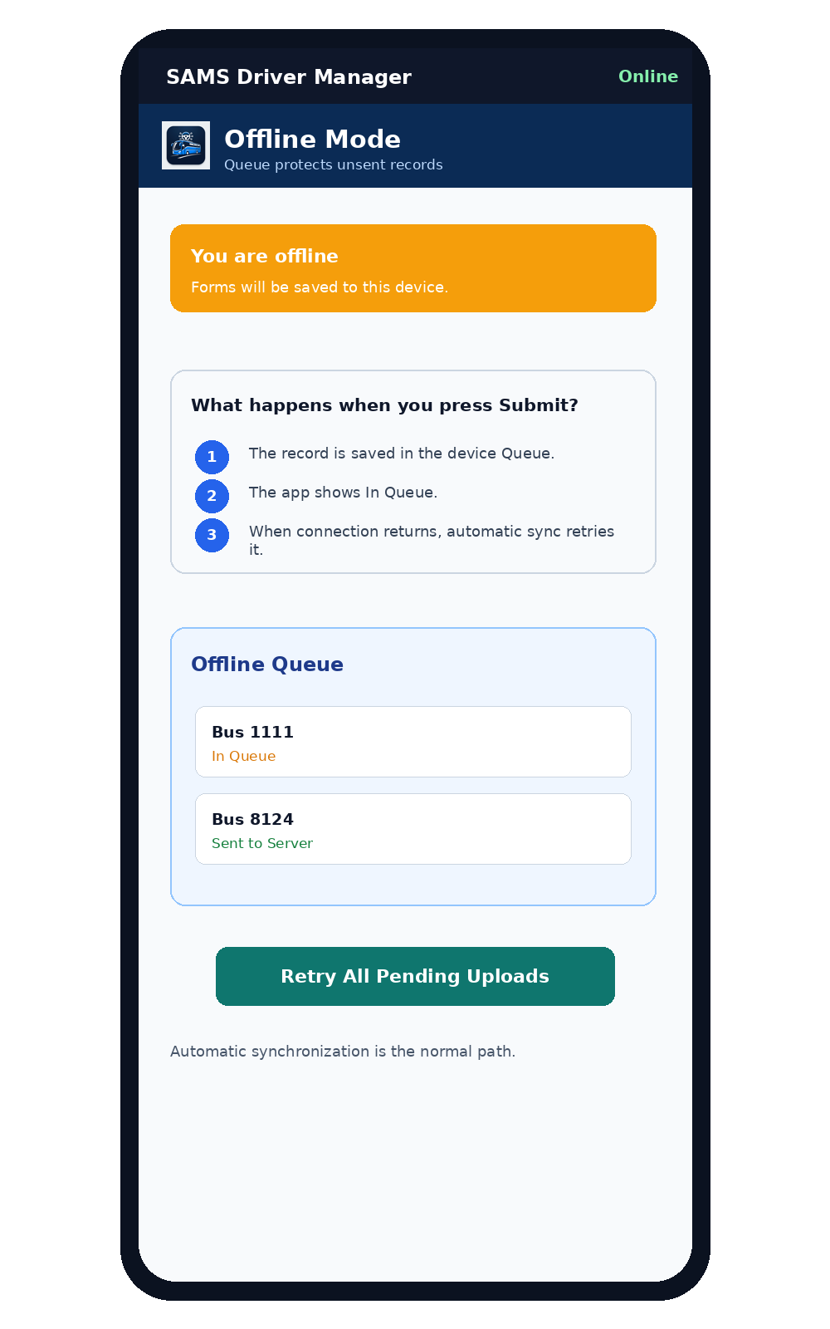
Illustrated screen: Offline Queue workflow

9. Session Buses
Open Session Buses to review the buses handled during the current employee session. Confirm bus number, parking location, mileage and status. Sent to Server means the server confirmed the record. In Queue means the record is still stored locally and waiting to synchronize.
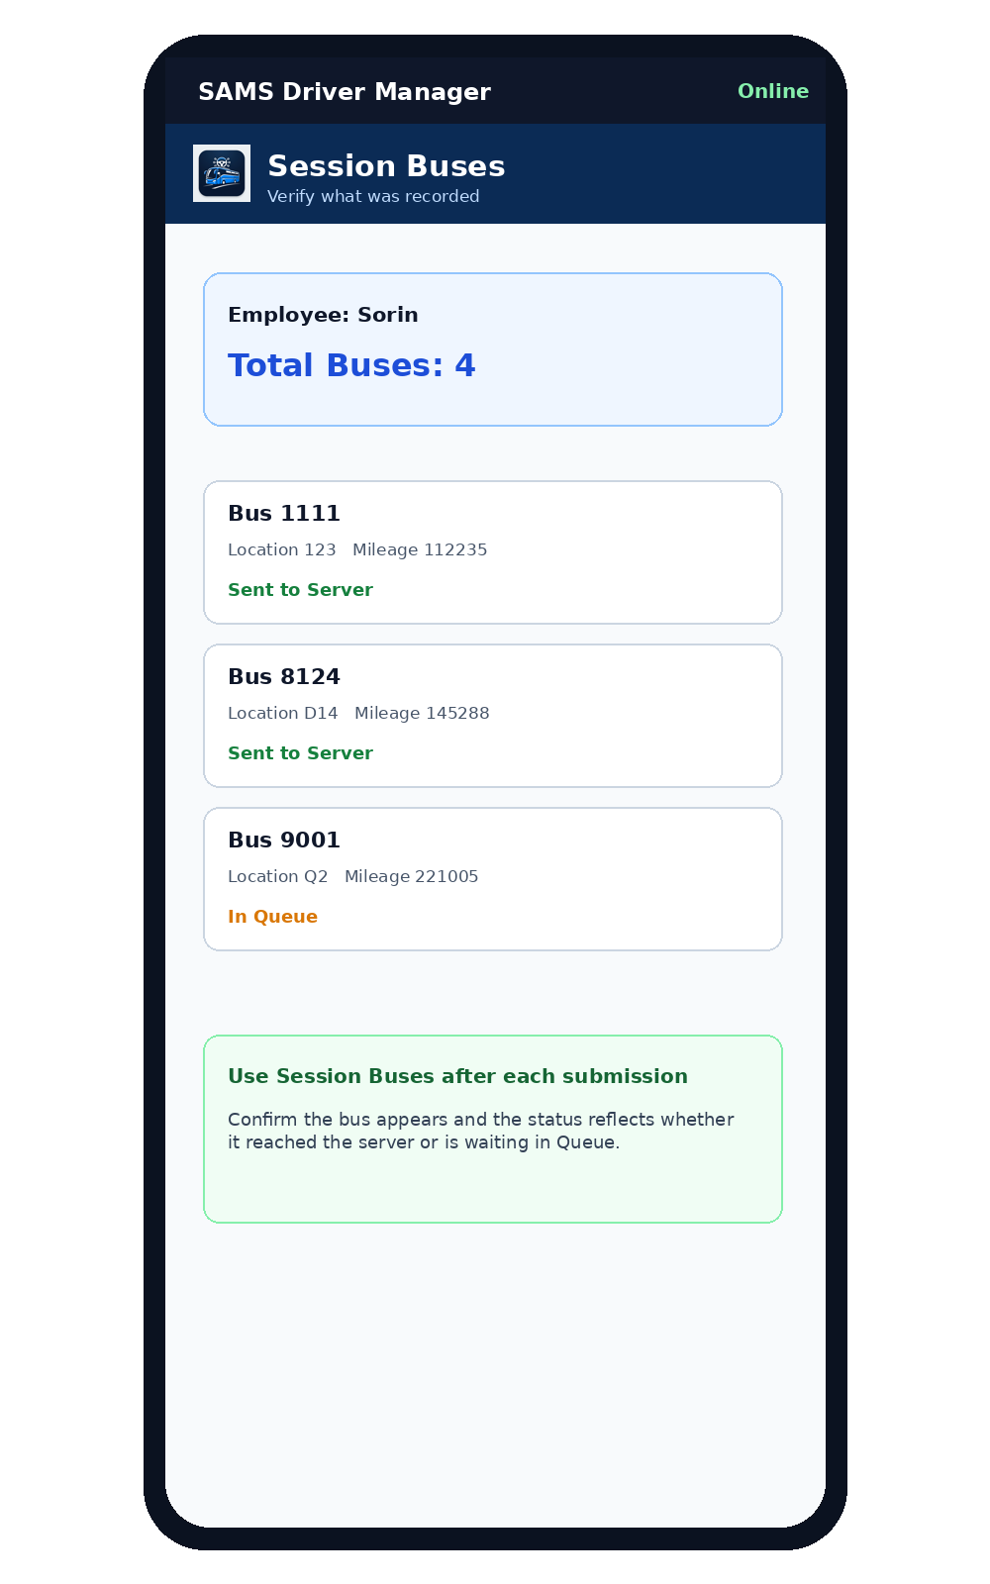
Illustrated screen: Session Buses

10. Safety Reminders
The Safety Reminders window appears when entering Driver Entry and may reappear after extended stationary time. Review the yard speed limit, garage speed limit, and the requirement to stop and check the light and door before entering or exiting the garage. Select Understood after reviewing the reminder.
- Yard maximum: 20 km/h.
- Garage maximum: 7 km/h.
- Stop and check the light and door before entering or exiting the garage.
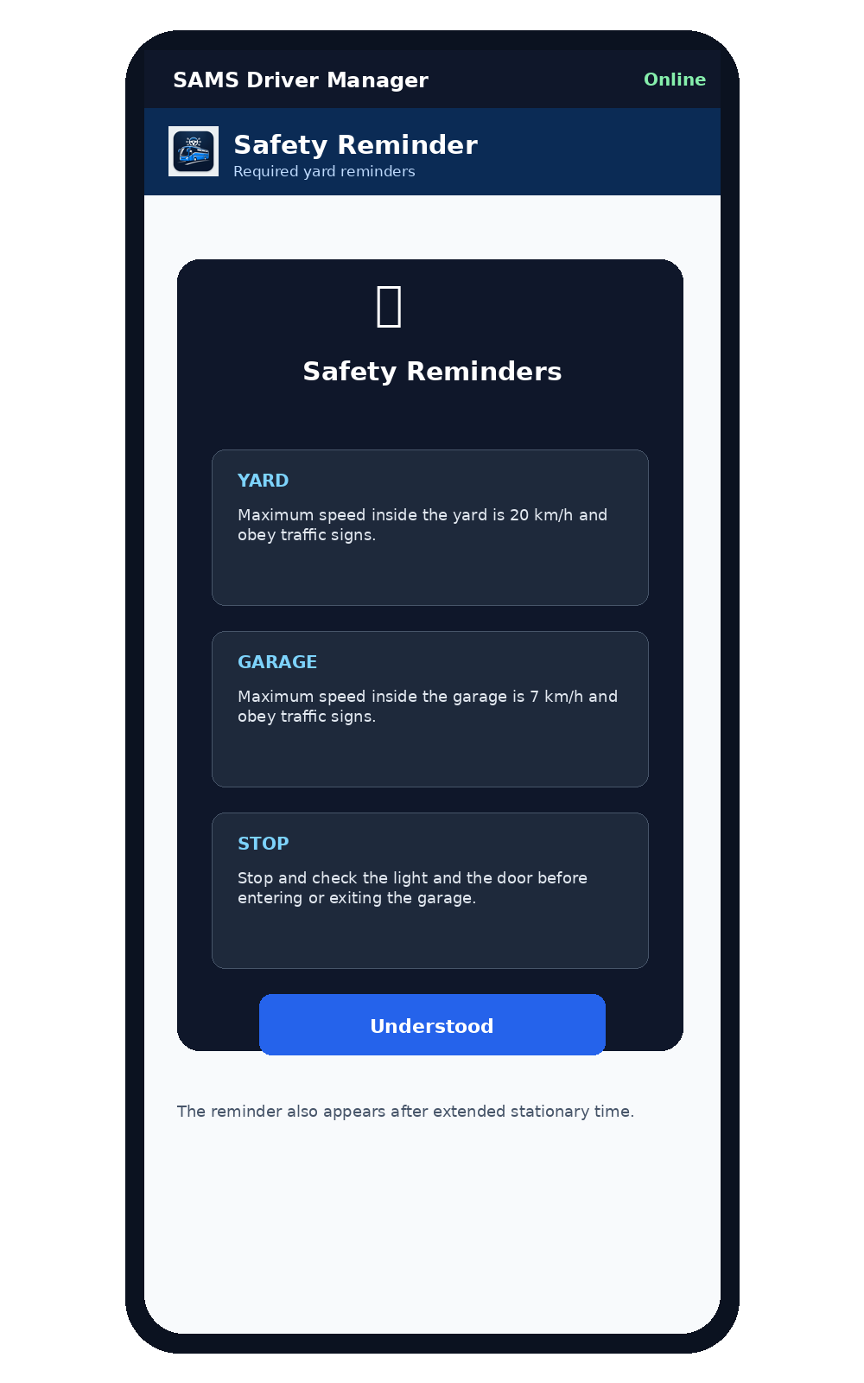
Illustrated screen: Safety Reminders

11. Inactivity and automatic sign-out
After 25 minutes without activity, the app shows a five-minute inactivity warning. Select Stay Signed In to continue the session. At 30 minutes without activity, the employee is automatically signed out. Queue records are preserved. Normal touch, input, selection and navigation activity resets the timer.
- 25 minutes: warning appears.
- 30 minutes: automatic sign-out.
- Stay Signed In resets the inactivity timer.
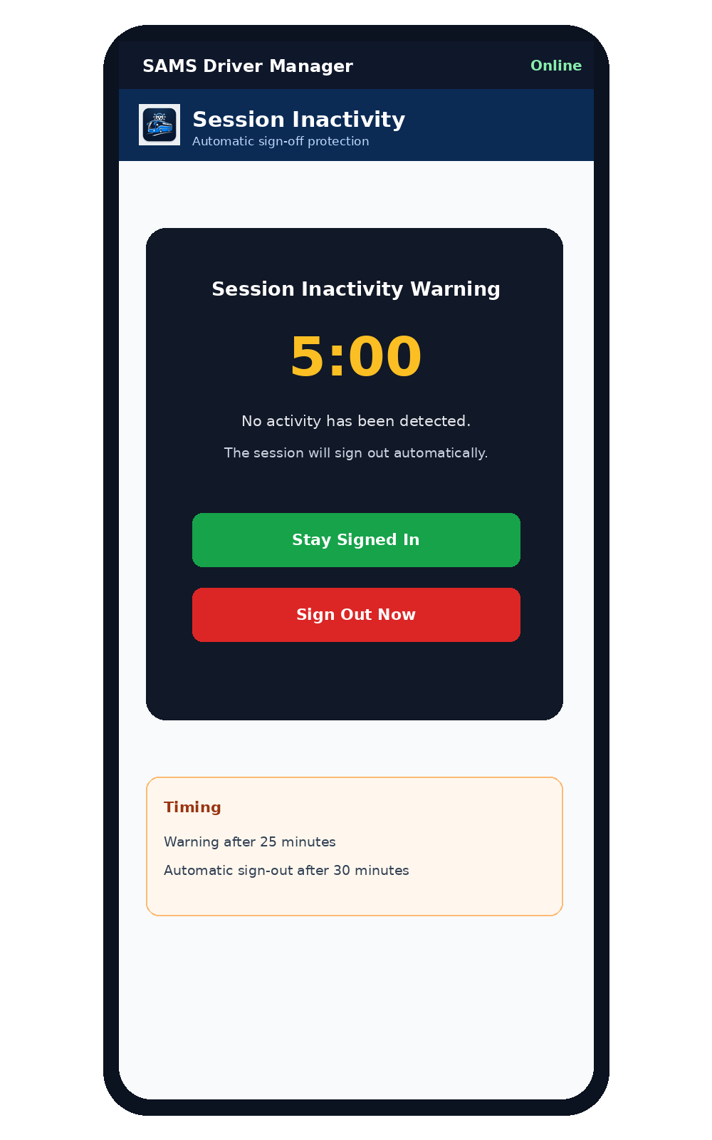
Illustrated screen: Inactivity warning and automatic sign-out

12. Settings and User Manual
Settings displays session information and provides access to Safety Reminders, the User Manual and End Session / Logout. Use the User Manual button to reopen this guide from inside the app.
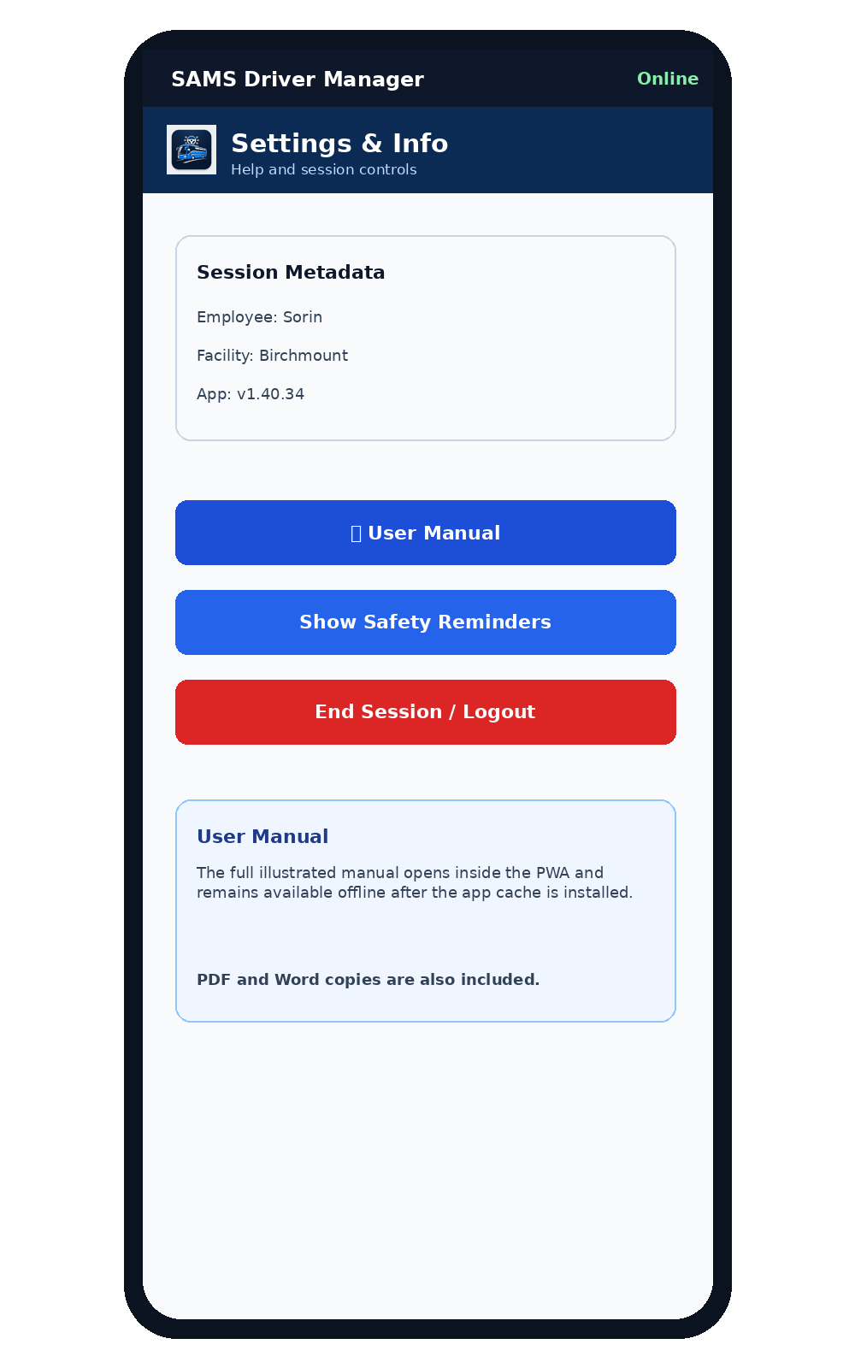
Illustrated screen: Settings and in-app User Manual

13. Troubleshooting
If the camera cannot open, verify browser camera permission and return to the PWA without clearing site data. If a record is offline, check the Queue and allow automatic synchronization after connectivity returns. If the app shows an older version after deployment, use the supplied force-update page. Never clear IndexedDB or site storage as a troubleshooting step unless authorized, because pending Queue records may be lost.
- Camera problems: verify camera permission; do not clear storage.
- Old app version: use the force-update page supplied with the release.
- Offline record: review Queue and wait for connectivity before manual retry.

14. End-of-session checklist
Before signing out: confirm all buses handled are visible in Session Buses, review the Queue for pending uploads, verify any required photos and defect notes, and then use End Session / Logout. Sign-out clears the active login and entry fields but keeps pending Queue records.

Quick Reference Checklist
- Before Submit: Bus Number, Mileage and Parking Location are complete.
- Defects: check only conditions actually observed.
- Photos: confirm previews before submitting.
- Offline: verify In Queue status and allow automatic synchronization.
- After Submit: verify the bus in Session Buses.
- Safety: review reminders and select Understood.
- Licence: act on expiry warning if shown.
- End Session: review Session Buses and Queue, then sign out.
Support note: Do not delete browser storage, IndexedDB or Queue data as a routine troubleshooting step.

